Ryan Evan Fissell (from The Katy Times)
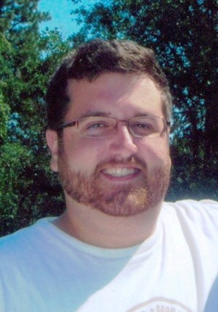
Ryan Evan Fissell was born on July 15, 1988 in Bakersfield, California to Mark and Nanette Fissell. Ryan was a 2006 graduate of Cinco Ranch High School, as well as a 2011 graduate from the Bio-Technology Program at the University of Houston. He was a member of the Bio-Tech Society of Greater Houston and attended The Fellowship at Cinco Ranch Church in Katy.

Ryan passed away at his home, in Katy, on Friday, February 10, 2012, at the age of 23 years.

He is survived by his parents, Mark and Nanette Fissell of Katy; brothers, Alex and Collin Fissell, both of Katy; grandmother, Rosemarie Fissell of Katy; grandfather, Dennis Louviere of New Iberia, Louisiana; as well as aunts and uncles, Dan and Sue Fissell of Dufer, Oregon, Denny Louviere of New Iberia, Louisiana, Kevin Louviere of Arlington, Texas, and Blaise and Sandra Louviere of New Iberia, Louisiana.

He was preceded in death by his grandfather, Don Fissell; and his grandmother, Gayle Louviere.

A memorial service will be held at 12:00 noon on Saturday, February 18, 2012 at The Fellowship at Cinco Ranch Church in Katy with Dr. Jerry Edmonson and Gail Edmonson officiating.

Those wishing to make memorial gifts may do so to the American Heart Association, P.O. Box 15186, Austin, TX 78761-5186; or to the Leukemia & Lymphoma Society, Texas Gulf Coast Chapter, 5005 Mitchelldale, Suite 115, Houston, TX 77092-7230.
Funeral services held under the direction of Schmidt Funeral Home, 1508 East Avenue, Katy, Texas 77493, 281-391-2424.

